**Biophilia Effect:**

**Environments rich in nature views and imagery reduce stress and enhance focus and concentration.**

Nature can be a dangerous place, especially for humans. In the wilderness, threats are often real and immediate. Yet taking someone from the “safe” comforts of civilization and into the wilderness normally reduces their stress level. Think of your own experiences in nature. Be it walking, hiking, camping, or otherwise, chances are that you have experienced the stress-relieving power of natural settings. This influence, known as biophilia, or [love of life](https://www.psychologytoday.com/us/basics/biophilia) , is a powerful mechanism that designers and educators can capitalize on to increase desired learning outcomes and overall system effectiveness. The universal design principle of the biophilia effect states that environments rich in nature views and imagery reduce stress and enhance focus and concentration. Conducting a course, or lesson, in nature can be engaging and impactful for both the facilitator and the student. When suitable designers and educators should consider natural setting as advantageous to learning outcomes. However, we do not have to take the class into the wilderness to reap some of the benefits, we can bring nature to the class. There is a veritable mountain of research showing the positive impact natural environs have on the human condition, both in the realms of [psychology](https://www.ncbi.nlm.nih.gov/pmc/articles/PMC2760412/) and [design](https://pdfs.semanticscholar.org/9161/3fb7292b2509ac8c33b9d432c6c8713ef4d4.pdf) . Designers and educators can incorporate the effect by strategically using settings that afford nature views, by positioning plants throughout a learning space, and by using nature-oriented wall coverings and backdrops.

Incorporating the biophilia effect as part of the learning environment can [help](https://positivepsychology.com/positive-effects-of-nature/) the facilitator and student by reducing negative stress, increase attention, concentration, and engagement. All of which are paramount to learning effectiveness and aids the educator in meeting the [UDL](http://udlguidelines.cast.org/) guideline of Recruiting Interest via minimizing threats and distractions. The human affection for verdant environments has evolutionary roots. It makes sense that our brains, and thus we, would feel more at home and at peace when our surroundings reflect the presence of flora and conditions that meet our most basic needs. This also aligns with the universal design principle of savannah preference. In such environments, we may feel free of previously perceived threats and therefore can open our minds to other possibilities. We are better able to attend to the present moment; thus, the student can actively engage with the material at hand. This is no voodoo magic, but a [fundamental truth](https://www.psychologytoday.com/us/blog/animal-emotions/201801/the-biophilia-effect-exploring-the-healing-power-nature) of the human condition. Simply put, our brains are wired to thrive in nature.

**Create a classroom outside**

Hosting classes outdoors comes with its own unique set of challenges and opportunities. We may be able to reduce stress and anxiety, and bring about feelings of serenity, but without appropriate engagement it can be easier for the audience to become distracted. This image shows the example of a classroom that might be good for brief discussions and as a transition point to more hands-on or interactive content. Weather can be a factor as well, but the payoff is often worth it!

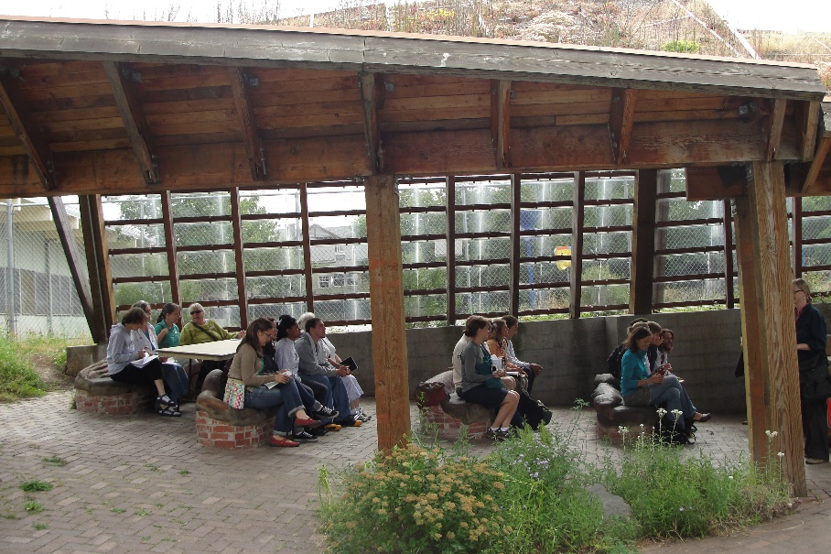

**Nature themed wall covering**

Introducing nature-based wall covering to a learning space is a great way to bring an outdoor feel into a building or classroom. This can be especially helpful when there are no windows or the windows show only urban environments. Another positive component of using wallcovering is that It can be changed to reflect the content being covered. Here is an example that takes an otherwise sterile white space and brings it to life with wall covering that captures a path through the woods. The path in the picture seems to synergize well with this transition area.

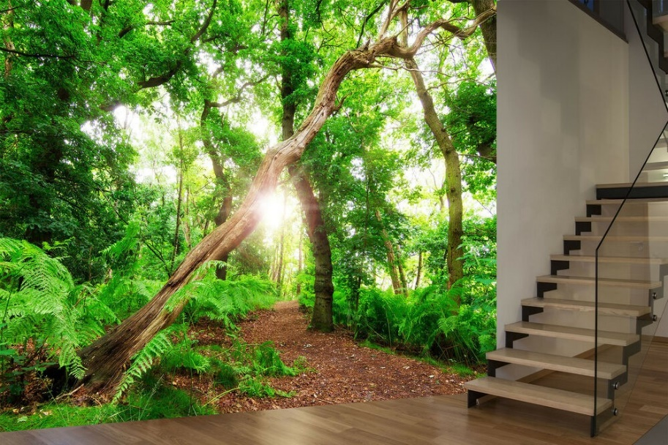

**Window views**

Windows do not have to overlook some grand natural Vista to have a positive impact on the learning environment. By introducing a few trees and shrubs, where available, we can immediately change the feeling the student gets when gazing out the window. Projects like this have a potential dual benefit as planting the trees and shrubs can be part of the class itself. It may not be much but imagine this view without the tree. Even a little nature can have and noticeable impact.

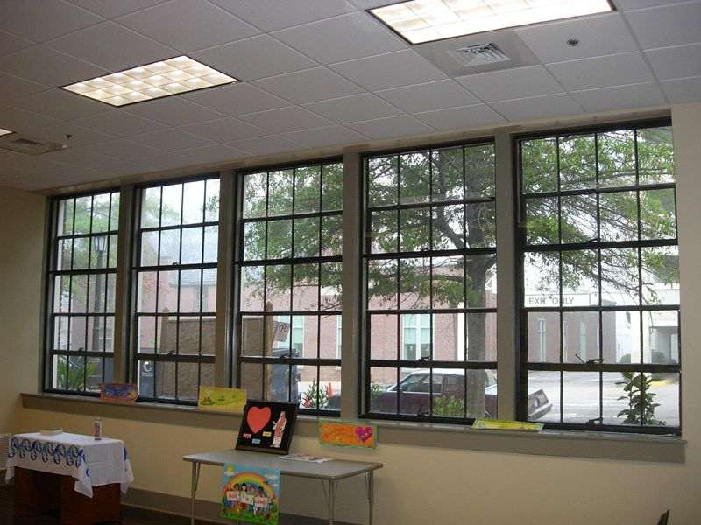

**Nature assignments**

Classes can come alive in a whole new way when we can view and interact the topic of discussion as part of the lesson. Here we see a real strength of learning in an outdoor environment, and that is hands-on engagement and interactivity. The tangible beauty of this approach is that it is not just tied to the natural sciences. We can discuss social and cultural impacts as well as mathematical concepts that surround us every day. Nature provides us a limitless laboratory of possible topics, experiments, and memorable experiences.

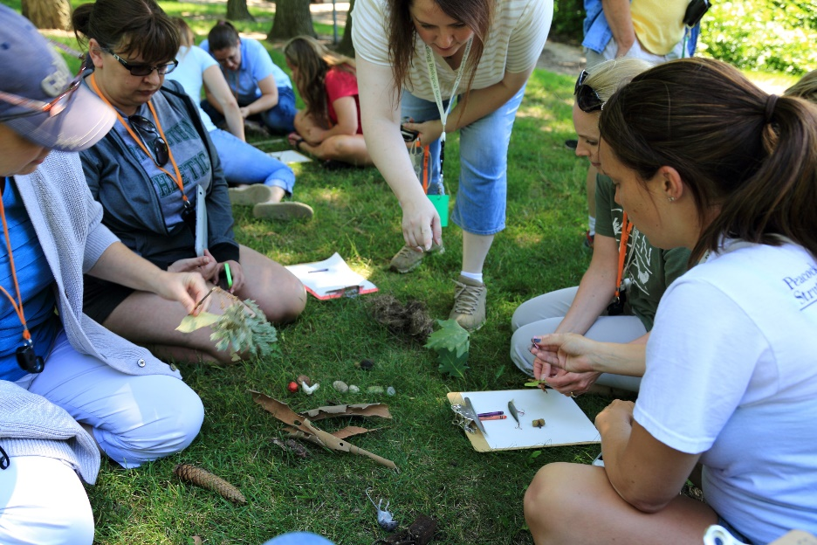

**Classroom garden**

One of the most empowering examples of the biophilia effect is to witness humans growing plants for the first time. Having a garden in the classroom gives the educator a range of possible desired outcomes. They can be used to facilitate biology, home economics, or agriculture science classes, but perhaps more importantly, by bringing plants into the classroom, it impacts both the feel of the classroom and the way humans behave within that space. Here we see an example of a hydroponic garden using nutrient film technique, but with a few packets of seeds and some soil, almost any container can become a garden .

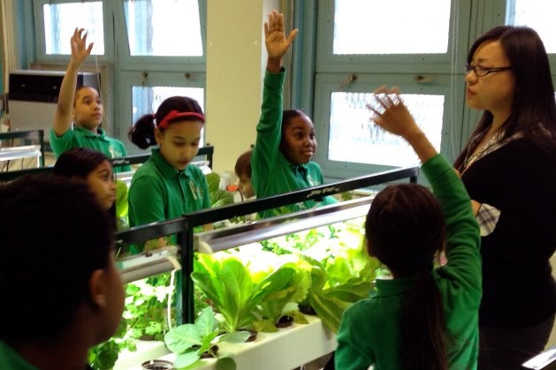

**Overcome challenges - bonus example**

Something almost magical happens when we face and overcome challenges in the outdoors. As discussed above, research shows it is not magic but a result of our makeup . Here we see a confidence building challenge being conquered by a young student. This exercise is outdoors but we can replicate much of the effect by bringing plants into our indoor learning spaces.

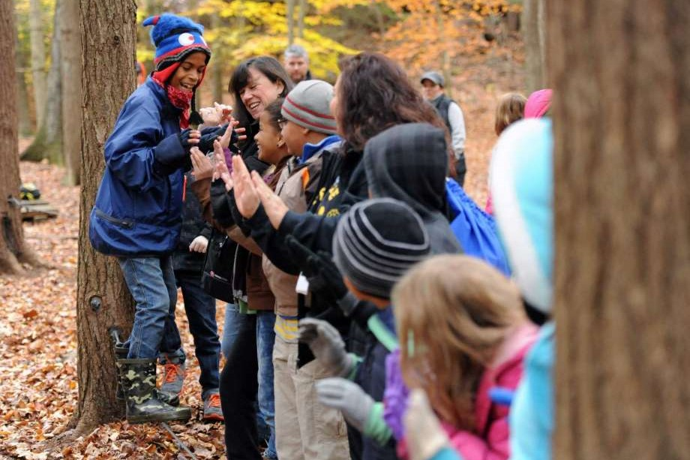

Duane Gregory - WTAMU course 6310 - Summer II - 2020